**CONTACT:**

Dr. Kelly McBride, Director of PR/Media Relations

[Dr.kmcbride@emeraldvinesmedia.com](mailto:Dr.kmcbride@emeraldvinesmedia.com)

Cell 717-327-1908

**NEWS RELEASE**

**For Immediate Release**

**November 9, 2021**

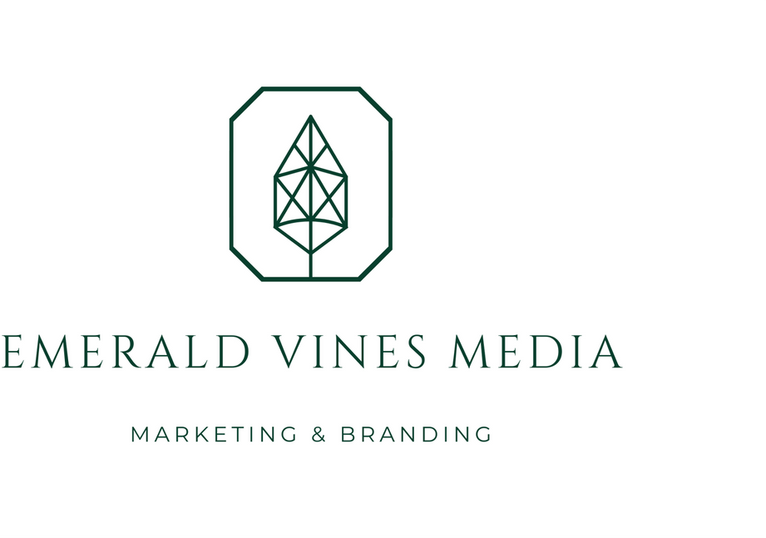

**A ‘GRAPE’ DONATION IN TIME FOR VETERAN’S DAY**

*Orlando, Fla. Based Foundation Presents Check to Tunnel to Towers Orlando*

VENICE, Fla. – [Silk Road Wines](http://www.silkroadwines.com/), a division of AG Global Trade LLC yesterday presented a check to the Tunnel to Towers Foundation of Orlando in the amount of $24,000. The amount represents a portion of funds raised at the inaugural [First Annual Wine for Warriors Gala](https://www.wineforwarriorsgala.com/), which was held on September 11 at Rosen Shingle Creek, Orlando. Accepting for the organization were Victoria Casas and Kyle and Ralph Albano.

The Tunnels to Towers Foundation Orlando is part of the New York City based [Tunnel to Towers Foundation](https://t2t.org/) that honors the legacy of Stephen Siller, FDNY, who ran through the Brooklyn Battery Tunnel to the World Trade Center on 9/11 to help save others. Their mission is to follow Stephen’s footsteps through support of children who have lost a parent, firefighters and military who have been seriously injured and sacrifice their quality of life in the line of duty.

“We are so thrilled to present this check to the Orlando Tunnel for Towers,” said Barry Greer, a part owner and partner with Silk Road Wines. “Our company’s CEO, [Yanick Arakelov](https://www.linkedin.com/in/yanick82/), is a U.S. veteran of the Afghanistan war, and currently serves as a major in the Army Reserves. Our Silk Road Wines Foundation is committed to helping veterans and first responders as part of our mission.”

Silk Road Wines is the largest distributor of wines from the country of Georgia in Florida. Georgia has been recognized by UNESCO as the oldest wine producing country in the world dating back 8,000+ years. The Second Annual Wine for Warriors is scheduled for Saturday, Sept. 10, 2022. For further information about attending next year’s event please visit the Silk Road website at www.silkroadwines.com.

###

Founded in 2020 and located in Orlando Fla., Emerald Vines Media LLC provides marketing, public relations,

branding, media relations, and crisis communications within the wine industry.

**3020 Eunice Ave., Suite B Orlando, FL 32808 • www. emeraldvinesmedia. Com**

*Photo: Barry Greer and Sharon Arakelov, owners of Silk Road Wines LLC, present a check in the amount of $24,000 to the Tunnel to Towers Foundation of Orlando. L-R: Barry Greer, Sharon Arakelov from Silk Road Wines; Kyle Albano, Victoria Casas and Ralph Albano from Tunnel to Towers Orlando*.